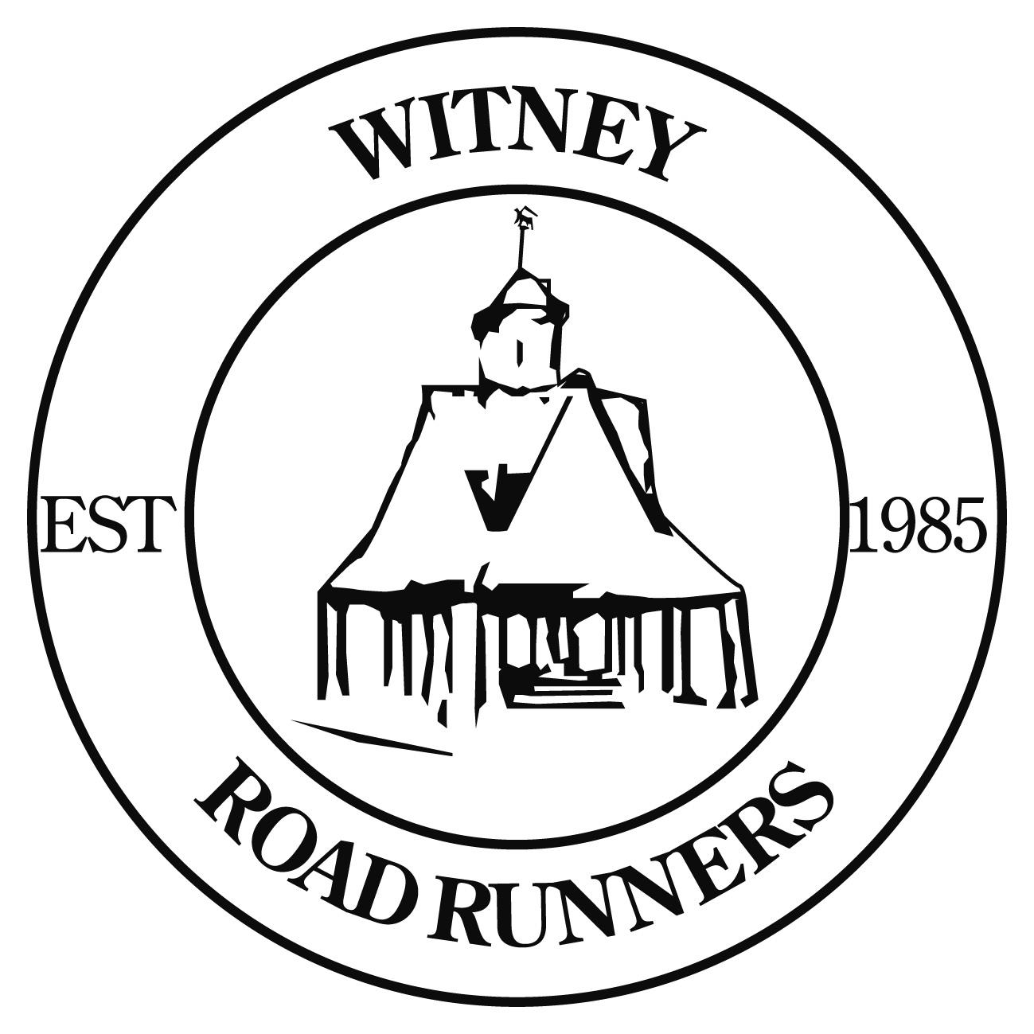

 Follow @witneyroadruns

WRR Newsletter for Monday 4th January 2021

WRR Club Trumps

We're creating the first ever set of Witney Road Runners Club Trumps: a simple card game that I'm sure you'll be familiar with but featuring our fabulous members.

If you'd like to be immortalised on a card then complete the form at the following link and email the photo you'd like on your card to wrrdanw@gmail.com - submit by Sunday 10th January to be included!
https://forms.gle/VwGBJA4gVeL9biNc8

You can be on a card and not buy a deck. You can buy a deck without being on a card. You can do neither, or both. It's up to you!

And here's an example of what the cards will look like to whet your appetite!

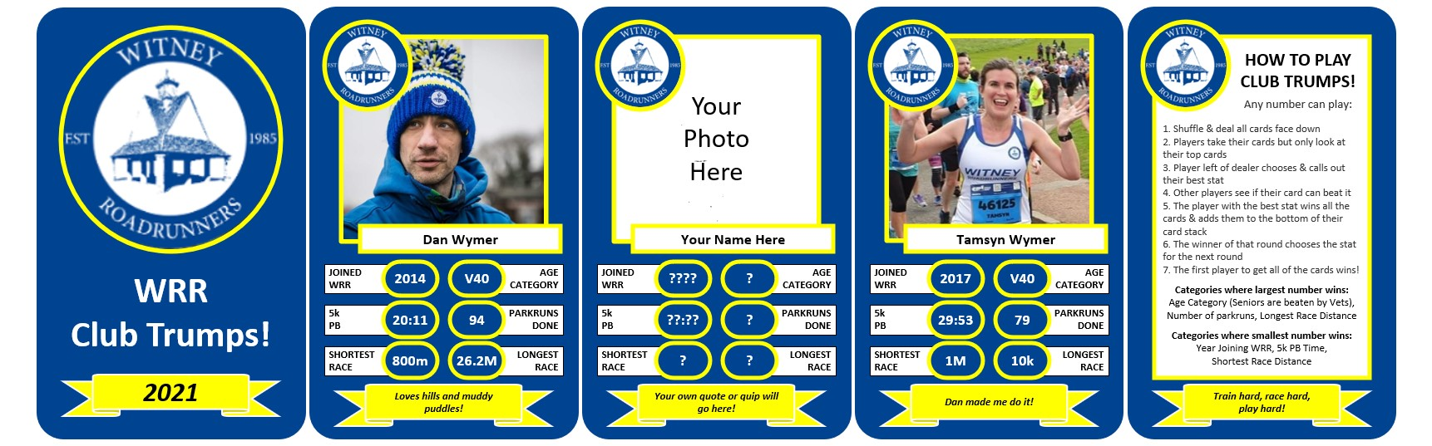

Card info and photos received from the following members so far: Dan Wymer, Anne Rouget, Bertie Field, Chris Ellis, Chris Miles, Martin Crabb, Fraser Howard, Ian Fowler, James Hackney, Jane Colbeck-McKinnon, Liam Walsh, Matt Lock, Mel Cassidy, Sam Upton, Toby Clarke, Tony Beardsley, Conrad Bailey, Stephen Roberts, Graham Le Good, Kiran Ram, Tamsyn Wymer, Lee Vanstone, Mark Johnson, Andy Green, Judith Le Good, Kirsty Yates, Tony Lock, Helen Train, Regina Lally, Allie Maybrey, Tegs Jones, James Currah.

EA Virtual Road Relay - Team WRR!

Great to see 50 members already signed up for the free, 5 Mile England Athletics Virtual Road Relay. There's still time to sign up - as long as you sign up and run your 5 miles before the end of next Sunday.

Your 5 miles can be run anywhere you want but needs to start and finish in the same place (within 200 metres) so can be out-and-back or loops (although loops can't be less than 1k).

Sign up here:
https://data.opentrack.run/en-gb/x/2020/GBR/earr/

Once you've run and logged on Strava or Garmin, you need to log back into OpenTrack to record your result and share your Strava/Garmin activity.

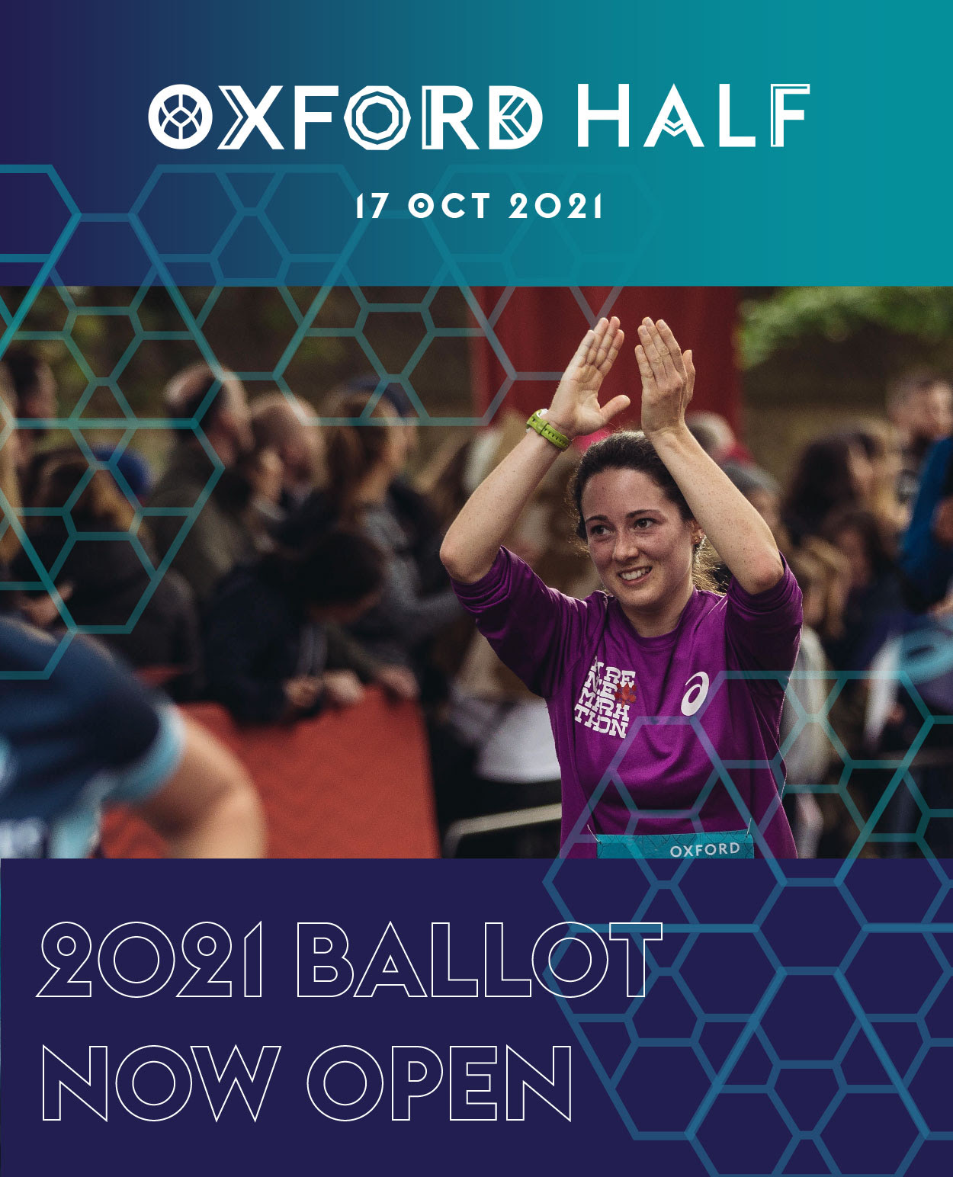

RESERVE 2021 RACE ENTRIES FOR CLUB MEMBERS!
Run, skip and smile past Oxford's world-famous museums, universities and parks for a day of Autumn cheer at our COVID-secure race day on 17th October 2021.
The ballot is now open and entries can be reserved for club places.
Please email me as soon as possible if you would like a place.
Lyn Hopkins
lynhopkins2@yahoo.co.uk

Results

NOT Parkrun
WRR (NOT) Parkruns link:
https://www.parkrun.org.uk/results/notparkrun/?date=2020-11-15&clubId=2326

This week

Tuesday
NO CLUB SESSION

Thursday
NO CLUB SESSION

Contacts
If you need any further information please contact:-
Chairman John McCormac
Secretary Lyn Hopkins
Membership Paul Rushby
League Races Andy Church
Newsletter Graham Le Good Andy Church
Tuesday sessions Graham Le Good
Thursday Routes Bertie Field
Short Run Rota Andy Church
Junior Rota Fraser Howard
Website Ian Fowler

WRR Club Kit Lyn Hopkins
Junior Club Mike Miles
Race Results WRR Results

